
Final Term Project Documentation

Project Name

University Admission Management System

Name | ID | Contribution
Sheikh Rubaeid Sanjid | 21-45844-3 | (33.34%)  Activity Diagram,  User Interface,  Query Writing
Abdullah Al Faisal | 21-45872-3 | (33.33% )  Project Proposal, Class Diagram, Schema Diagram
Wasifur Rahaman Chowdhury Alvi | 21-45856-3 | (33.33%)  Project Updates,  Use case diagram,  Relational Algebra

Course Name: Advance Database Management System
Section: A

Date of Submission: June 26, 2025

Project Updates:

ER Diagram:

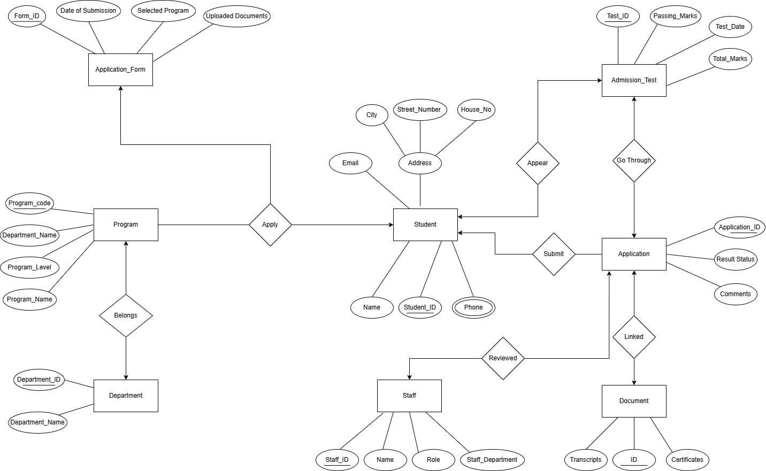
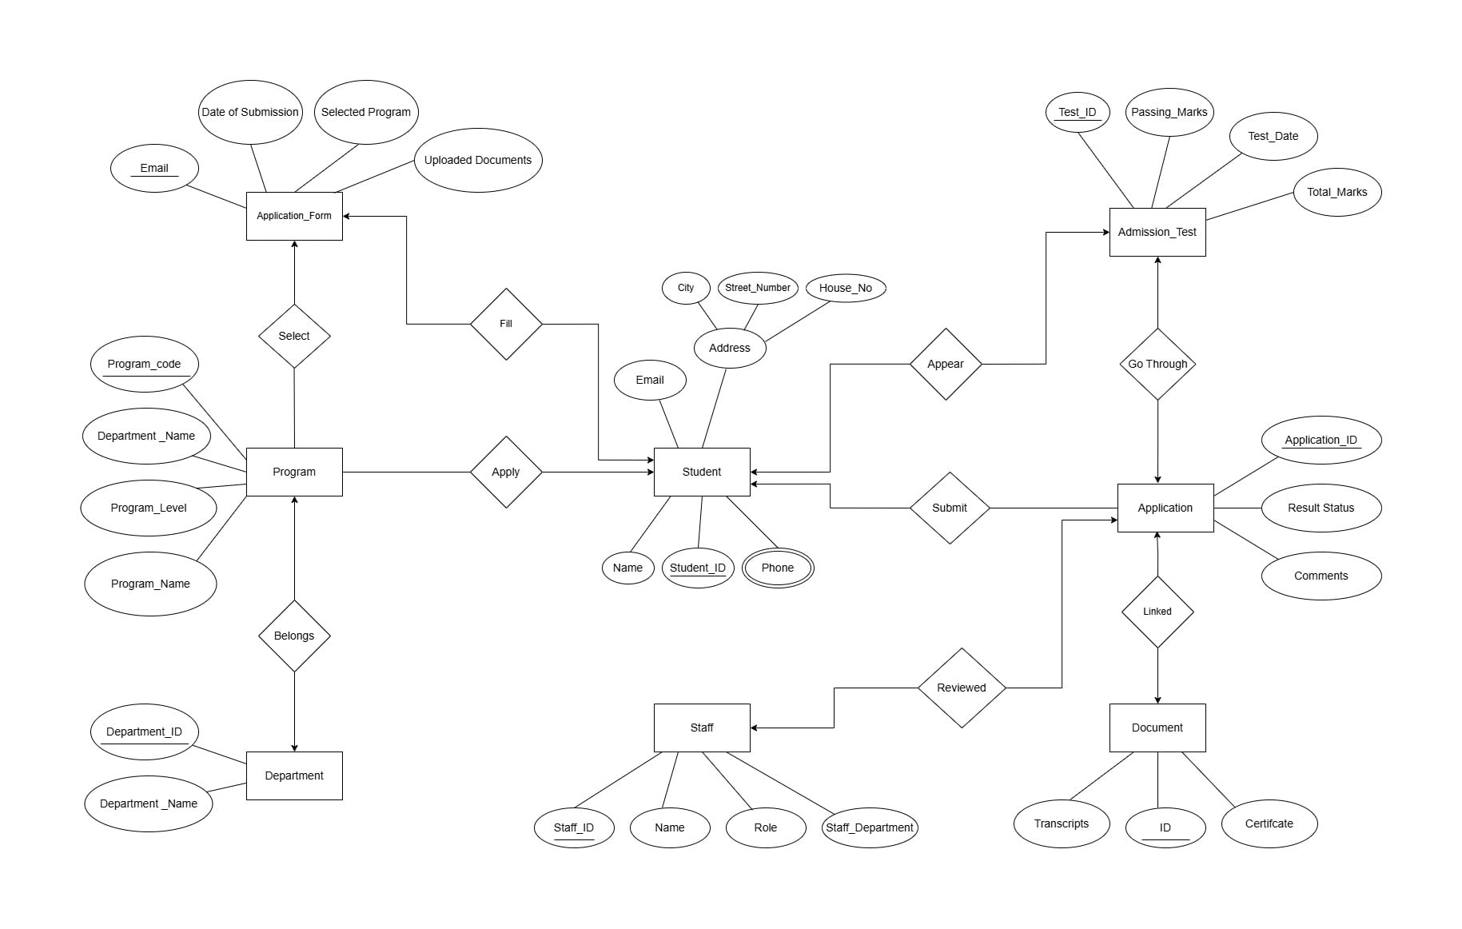

Updated Normalization:
Apply UNF
Apply (Student_ID, Name, Phone, Email, City, Street_No , House_No, program_code, department_name, program_level, program_name)

1NF
Phone is a multi valued attribute.
- Student_ID, Name, Phone, Email, City, Street_No , House_No, program_code, department_name, program_level, program_name

2NF
- Student_ID, Name, Phone, Email, City, Street_No , House_No,,
- program_code, department_name, program_level, program_name
- SFP_Id, Student_ID, program_code

3NF
- Student_ID, Name, Phone, Email, City, Street_No , House_No,
- program_code, program_level, DepPro_Id (FK)
- SFP_Id, Student_ID, program_code
- DepPro_Id, department_name, program_name

Table Creation
- Student_ID, Name, Phone, Email, City, Street_No , House_No,
- program_code, program_level, DepPro_Id (FK)
- SFP_Id, Student_ID, program_code
- DepPro_Id, department_name, program_name

Select
UNF
Select (program_code, department_name, program_level, program_name, email, date_of_submission, selected_program, uploaded_documents)
1NF
There is no multi valued attribute. Relation already in 1NF.
program_code, department_name, program_level, program_name, email, date_of_submission, selected_program, uploaded_documents
2NF
- program_code, department_name, program_level, program_name
- email, date_of_submission, selected_program, uploaded_documents
- program_email_id, program_code, email

3NF
- program_code, program_level, DepPro_Id (FK),
- email, date_of_submission, selected_program, uploaded_documents
- program_email_id, program_code, email
- DepPro_Id, department_name, program_name
Table Creation
- program_code, program_level, DepPro_Id (FK),
- email, date_of_submission, selected_program, uploaded_documents
- program_email_id, program_code, email
- DepPro_Id, department_name, program_name
FILL
UNF
Fill (Student_ID, Name, Phone, Email, City, Street_No , House_No, email, date_of_submission, selected_program, uploaded_documents)
1NF
Phone is a multi-valued attribute.
Student_ID, Name, Phone, Email, City, Street_No , House_No, email, date_of_submission, selected_program, uploaded_documents
2NF
- Student_ID, Name, Phone, Email, City, Street_No , House_No
- email, date_of_submission, selected_program, uploaded_documents
- student_email_id, student_id, email
3NF
There is no transitive dependency. Relation already in 3NF.
- Student_ID, Name, Phone, Email, City, Street_No , House_No
- email, date_of_submission, selected_program, uploaded_documents
- student_email_id, student_id, email
Table Creation
- Student_ID, Name, Phone, Email, City, Street_No , House_No
- email, date_of_submission, selected_program, uploaded_documents
- student_email_id, student_id, email

Belongs UNF
Belongs (program_code, department_name, program_level, program_name, department_id, department_name)

1NF
There is no multi valued attribute. Relation already in 1NF.
program_code, department_name, program_level, program_name, department_id, department_name

2NF
- program_code, department_name, program_level, program_name
- department_id, department_name
- DP_Id, program_code, department_id

3NF
- program_code, program_level, DepPro_Id (FK)
- department_id, department_name
- DP_Id, program_code, department_id
- DepPro_Id, department_name, program_name

Table Creation
- program_code, program_level, DepPro_Id (FK)
- department_id, department_name
- DP_Id, program_code, department_id
- DepPro_Id, department_name, program_name

Appear UNF
Appear (student_id, name, email, phone, city, street_number, house_no, test_id, passing_marks, test_date, total_marks)

1NF
Phone is a multi valued attribute.
- student_id, name, email, phone, city, street_number, house_no, test_id, passing_marks, test_date, total_marks

2NF
- student_id, name, email, phone, city, street_number, house_no
- test_id, passing_marks, test_date, total_marks
- ST_Id, student_id, test_id

3NF
- student_id, name, email, phone, city, street_number, house_no

- test_id, test_date, PT_Id (FK)
- ST_Id, student_id, test_id
- PT_Id, passing_marks, total_marks

Table Creation
- student_id, name, email, phone, city, street_number, house_no
- test_id, test_date, PT_Id (FK)
- ST_Id, student_id, test_id
- PT_Id, passing_marks, total_marks

Go Through UNF
Go Through (application_id, result_status, comments, test_id, passing_marks, test_date, total_marks)

1NF
There is no multi valued attribute. Relation already in 1NF.
- application_id, result_status, comments, test_id, passing_marks, test_date, total_marks

2NF
- application_id, result_status, comments,
- test_id, passing_marks, test_date, total_marks
- AT_Id, application_id, test_id,

3NF
- application_id, result_status, comments,
- test_id, test_date, total_marks
- AT_Id, application_id, test_id,
- PT_Id, passing_marks, total_marks

Table Creation
- application_id, result_status, comments,
- test_id, test_date, total_marks
- AT_Id, application_id, test_id,
- PT_Id, passing_marks, total_marks

Submit

UNF
Submit ( application_id, result_status, comments, student_id, name, email, phone, address, city, street_number, house_no)

1NF
Phone is a multi valued attribute.
- application_id, result_status, comments, student_id, name, email, phone, address, city, street_number, house_no

2NF
- application_id, result_status, comments
- student_id, name, email, phone, address, city, street_number, house_no
- AS_Id, application_id, student_id,

3NF
There is no transitive dependency. Relation already in 3NF
- application_id, result_status, comments
- student_id, name, email, phone, address, city, street_number, house_no
- AS_Id, application_id, student_id,

Table Creation
- application_id, result_status, comments
- student_id, name, email, phone, address, city, street_number, house_no
- AS_Id, application_id, student_id,

Linked UNF
Linked (application_id, date_of_submission, selected_program, uploaded_documents, document_id, transcripts, certificates)

1NF
There is no multi valued attribute. Relation already in 1NF.
- application_id, date_of_submission, selected_program, uploaded_documents, document_id, transcripts, certificates

2NF
- application_id, date_of_submission, selected_program, uploaded_documents,
- document_id, transcripts, certificates
- AD_Id, application_id, document_id,

3NF
There is no transitive dependency. Relation already in 3NF
- application_id, date_of_submission, selected_program, uploaded_documents,
- document_id, transcripts, certificates
- AD_Id, application_id, document_id,

Table Creation
- application_id, date_of_submission, selected_program, uploaded_documents,
- document_id, transcripts, certificates
- AD_Id, application_id, document_id,

Reviewed UNF
Reviewed (application_id, result_status, comments, staff_id, name, role, staff_department)

1NF
There is no multi valued attribute. Relation already in 1NF.
- application_id, result_status, comments, staff_id, name, role, staff_department

2NF
- application_id, result_status, comments
- staff_id, name, role, staff_department
- AS_Id, application_id, staff_id

3NF
There is no transitive dependency. Relation already in 3NF
- application_id, result_status, comments
- staff_id, name, role, staff_department
- AS_Id, application_id, staff_id

Table Creation
- application_id, result_status, comments
- staff_id, name, role, staff_department
- AS_Id, application_id, staff_id

Temporary Tables
- Student_ID, Name, Phone, Email, City, Street_No , House_No,
- program_code, program_level, DepPro_Id (FK)
- SFP_Id, Student_ID, program_code
- DepPro_Id, department_name, program_name
- program_code, program_level, DepPro_Id (FK),
- email, date_of_submission, selected_program, uploaded_documents
- program_email_id, program_code, email
- DepPro_Id, department_name, program_name
- Student_ID, Name, Phone, Email, City, Street_No , House_No
- email, date_of_submission, selected_program, uploaded_documents
- student_email_id, student_id, email
- program_code, program_level, DepPro_Id (FK)
- department_id, department_name
- DP_Id, program_code, department_id
- DepPro_Id, department_name, program_name
- student_id, name, email, phone, city, street_number, house_no
- test_id, test_date, PT_Id (FK)
- ST_Id, student_id, test_id
- PT_Id, passing_marks, total_marks
- application_id, result_status, comments,
- test_id, test_date, total_marks
- AT_Id, application_id, test_id,
- PT_Id, passing_marks, total_marks
- application_id, result_status, comments
- student_id, name, email, phone, address, city, street_number, house_no
- AS_Id, application_id, student_id,
- application_id, date_of_submission, selected_program, uploaded_documents,
- document_id, transcripts, certificates
- AD_Id, application_id, document_id,
- application_id, result_status, comments
- staff_id, name, role, staff_department
- AS_Id, application_id, staff_id

Final Tables
- Student_ID, Name, Phone, Email, City, Street_No, House_No,
- program_code, program_level, DepPro_Id (FK)
- SFP_Id, Student_ID, program_code
- DepPro_Id, department_name, program_name
- email, date_of_submission, selected_program, uploaded_documents
- program_email_id, program_code, email
- student_email_id, student_id, email
- department_id, department_name
- DP_Id, program_code, department_id
- test_id, test_date, PT_Id (FK)
- ST_Id, student_id, test_id
- PT_Id, passing_marks, total_marks
- application_id, result_status, comments,
- test_id, test_date, total_marks
- AT_Id, application_id, test_id,
- student_id, name, email, phone, city, street_number, house_no
- AS_Id, application_id, student_id,
- document_id, transcripts, certificates
- AD_Id, application_id, document_id,
- staff_id, name, role, staff_department
- AS_Id, application_id, staff_id

Updated Basic PL/SQL by removing random data:

Operators
Question 1:
"Compare if the student's total_marks are greater than the passing marks, and output if they passed or failed."
-- Project: University Admission Management System
-- Semester: Spring 2024-2025
-- Course: Advanced Database Management Systems
-- Section: A

DECLARE
v_student_id NUMBER := 1;
v_test_id NUMBER;
v_total_marks NUMBER;
v_passing_marks NUMBER;
v_result VARCHAR2(10);
BEGIN
SELECT test_id
INTO v_test_id
FROM student_test
WHERE student_id = v_student_id;

SELECT t.total_marks, p.passing_marks
INTO v_total_marks, v_passing_marks
FROM test t
JOIN passing_total p ON t.pt_id = p.pt_id
WHERE t.test_id = v_test_id;

IF v_total_marks >= v_passing_marks THEN
v_result := 'Passed';
ELSE
v_result := 'Failed';
END IF;
DBMS_OUTPUT.PUT_LINE('Result: ' || v_result);
END;
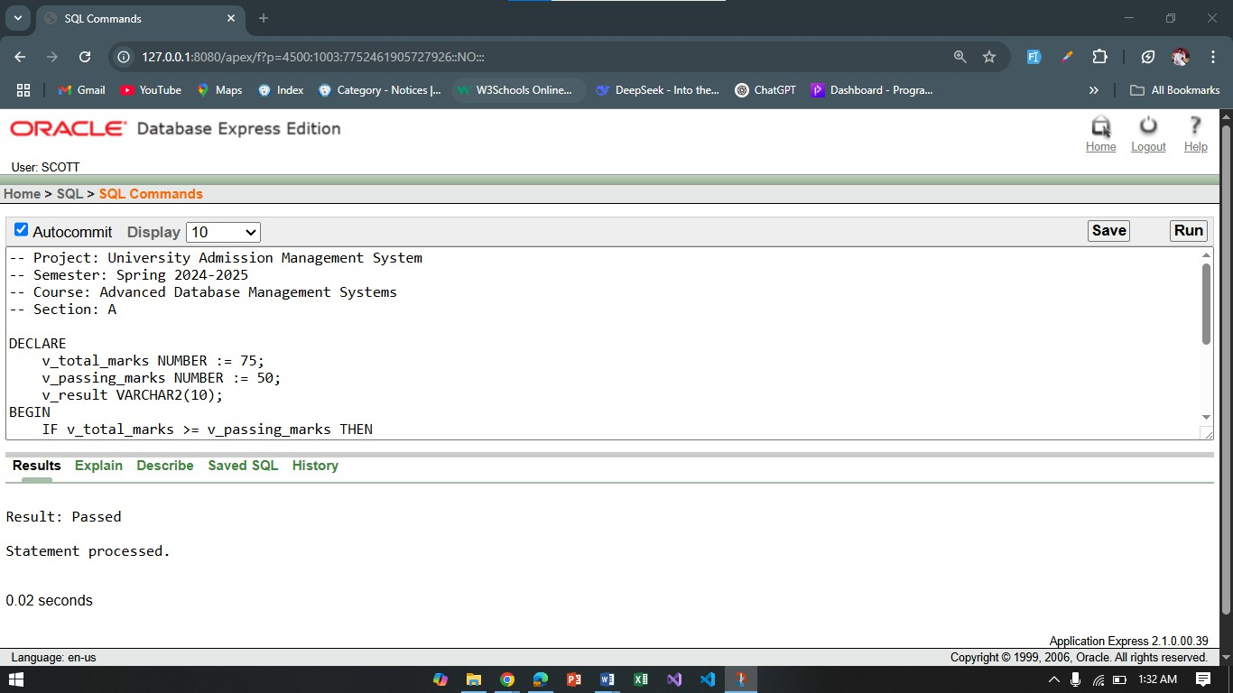

Question 2:
"Check if a student is in the top 5 based on their score."
-- Project: University Admission Management System
-- Semester: Spring 2024-2025
-- Course: Advanced Database Management Systems
-- Section: A

DECLARE
v_student_id NUMBER := 1;
v_score NUMBER;
v_is_top_5 VARCHAR2(10);
BEGIN
SELECT ST.total_marks
INTO v_score
FROM Student_Test ST
WHERE ST.Student_ID = v_student_id;

IF v_score >= (
SELECT MIN(ST2.total_marks)
FROM (
SELECT total_marks
FROM Student_Test
ORDER BY total_marks DESC
FETCH FIRST 5 ROWS ONLY
) ST2
) THEN
v_is_top_5 := 'Yes';
ELSE
v_is_top_5 := 'No';
END IF;
DBMS_OUTPUT.PUT_LINE('Is Top 5: ' || v_is_top_5);
END;
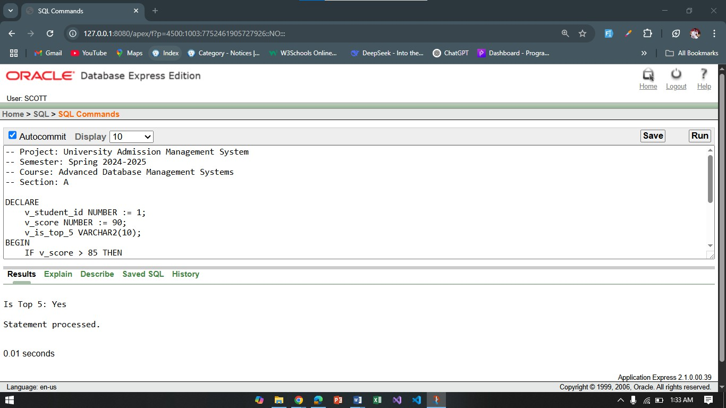

Conditional Statements
Question 2:
"Determine if a student has scored more than 60 marks."
-- Project: University Admission Management System
-- Semester: Spring 2024-2025
-- Course: Advanced Database Management Systems
-- Section: A
DECLARE
v_student_id NUMBER := 1;
v_score NUMBER;
BEGIN
SELECT ST.total_marks
INTO v_score
FROM Student_Test ST
WHERE ST.Student_ID = v_student_id;
IF v_score > 60 THEN
DBMS_OUTPUT.PUT_LINE('Student has scored more than 60 marks.');
ELSE
DBMS_OUTPUT.PUT_LINE('Student has scored less than 60 marks.');
END IF;
END;
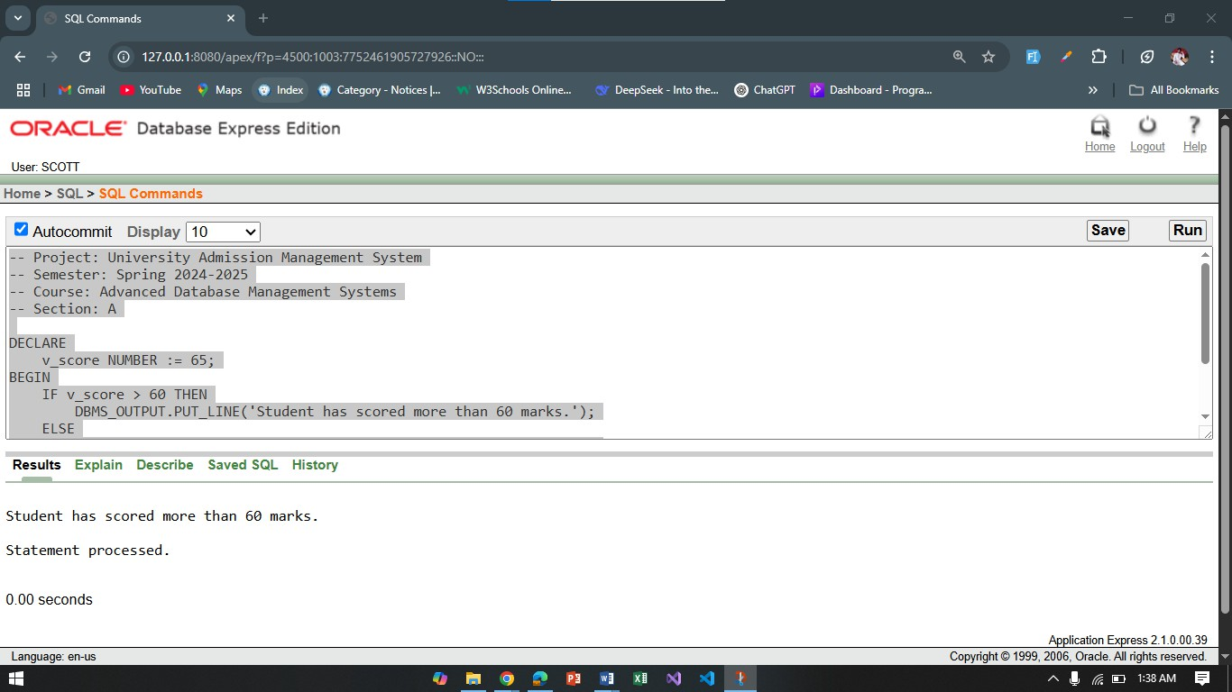
Project Proposal:
Overview
The University Admission Management System is designed to simplify and automate the university admission process. This system aims to handle the application process for students, manage student data, and assist university staff in reviewing and processing applications. The system will use a centralized database to store key information such as student details, application forms, program offerings, and admission results. The primary goal of the system is to reduce manual work, minimize errors, and accelerate the admission process.

Project Objectives
The main objectives of the University Admission Management System are:
- Simplifying the Admission Process: Providing an online platform where students can easily apply for different programs, fill out personal and academic information, and submit their application forms.
- Streamlining Data Management: Storing all student and program data in a safe, organized, and easily accessible database, ensuring data integrity and security.
- Enhancing Reporting and Monitoring: Generating reports for administrators to review student applications, track their status, and make informed decisions.
- Improving Communication and Transparency: Allowing students to check the status of their applications in real-time, ensuring better communication and transparency throughout the process.
- Admin Panel for Efficient Management: Providing an admin panel for university staff to review, approve, or reject applications, making the entire application process more efficient.

Key Features of the System
- Student Application Form: Online form for students to submit their personal and academic information. Option to upload supporting documents.
- Database Management: Secure and organized storage of all student, program, and application data.
- Application Status Tracking: Students can log in to track the status of their applications.
- Admin Panel: Admins can review student applications, check completeness, and approve or reject applications.
- Reporting and Analytics: Generate statistical reports on application trends, acceptance rates, and other key metrics for university staff.

Benefits of the System
For Students:
- Easy access to the application form and submission process.
- Transparent application status tracking, reducing uncertainty.

For University Staff:
- Streamlined process for managing and reviewing applications.
- Real-time updates and reports for better decision-making and less administrative work.

For the University:
- Reduced errors and human intervention in the admission process.
- Increased efficiency in managing applications and making admission decisions.
Technologies to be Used
- Frontend: HTML, CSS, JavaScript for building the user interface.
- Backend: Database management system using Oracle, and server-side using PHP.

Class Diagram, Use Case Diagram, Activity Diagram
Class Diagram:
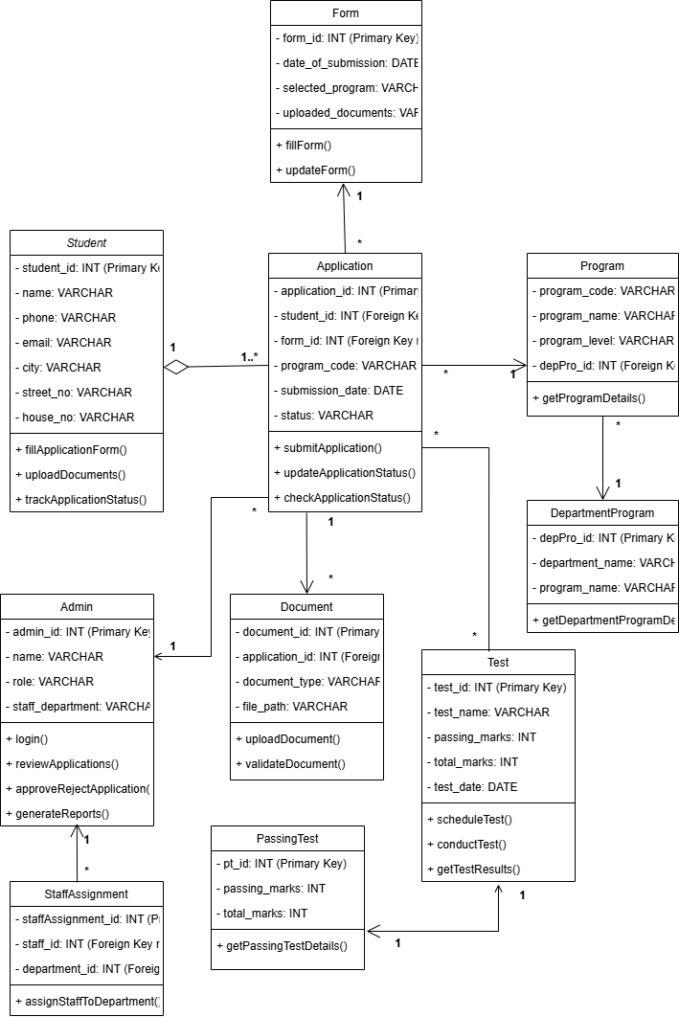

Use Case Diagram:
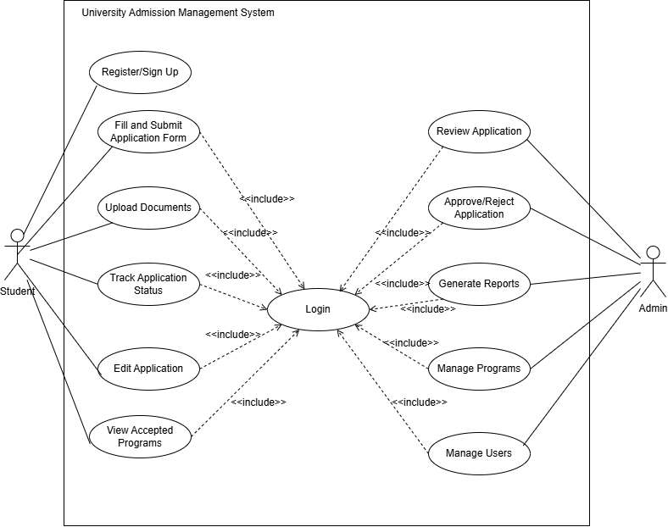

Activity Diagram:
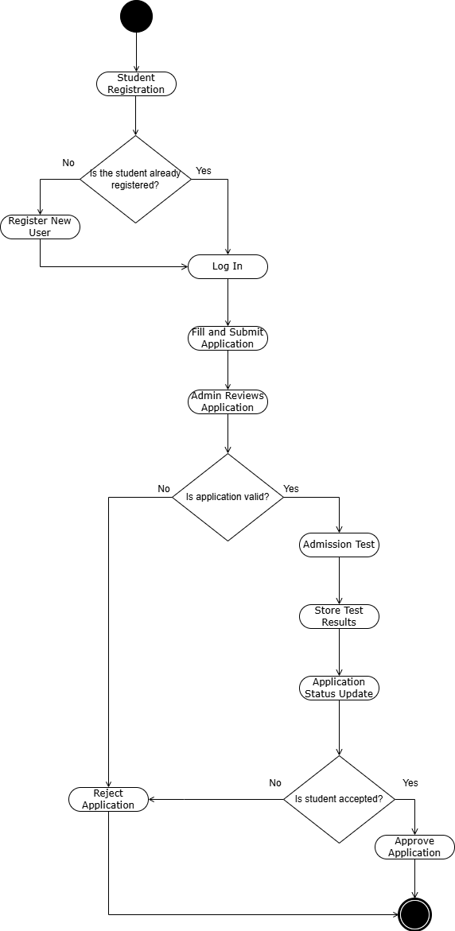

Schema Diagram:
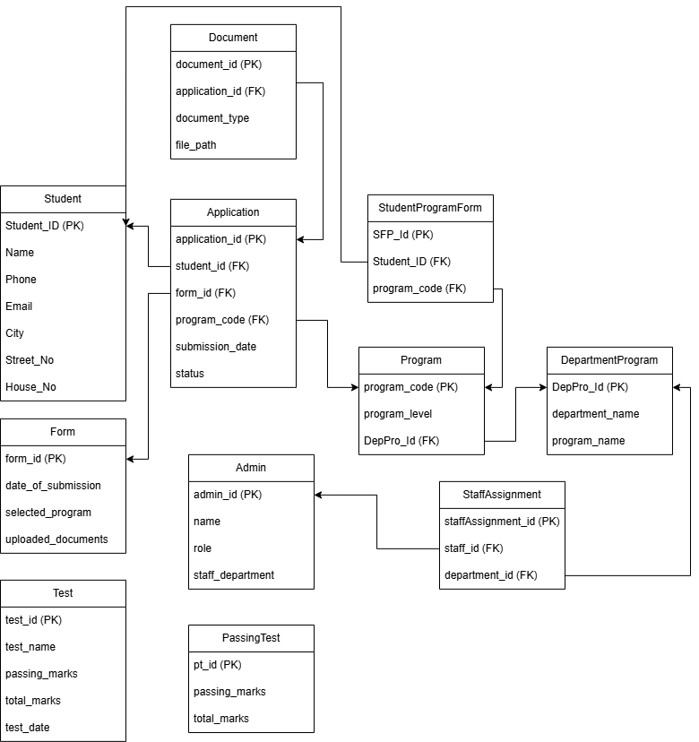

User Interface:

Mid Term User Interface Design:

Figure: Landing Page

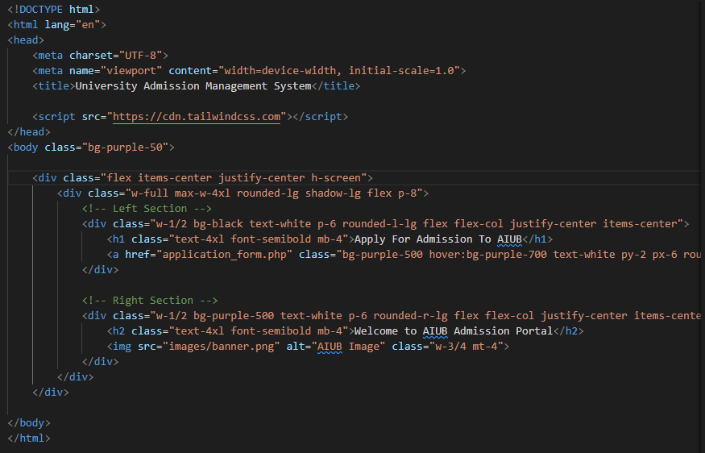

Figure: Signup Page

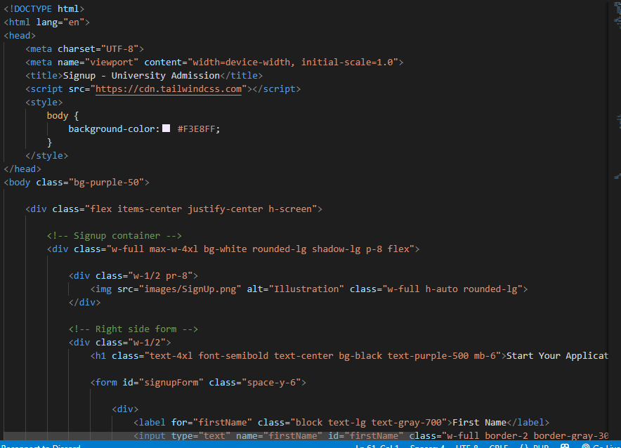


Figure: Login Page

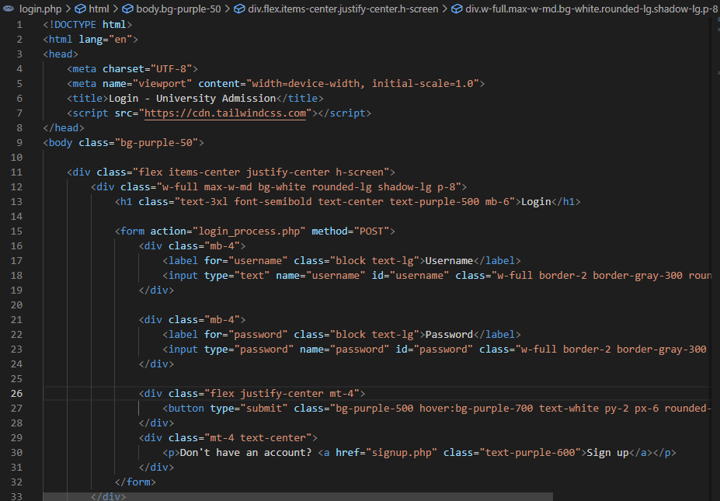
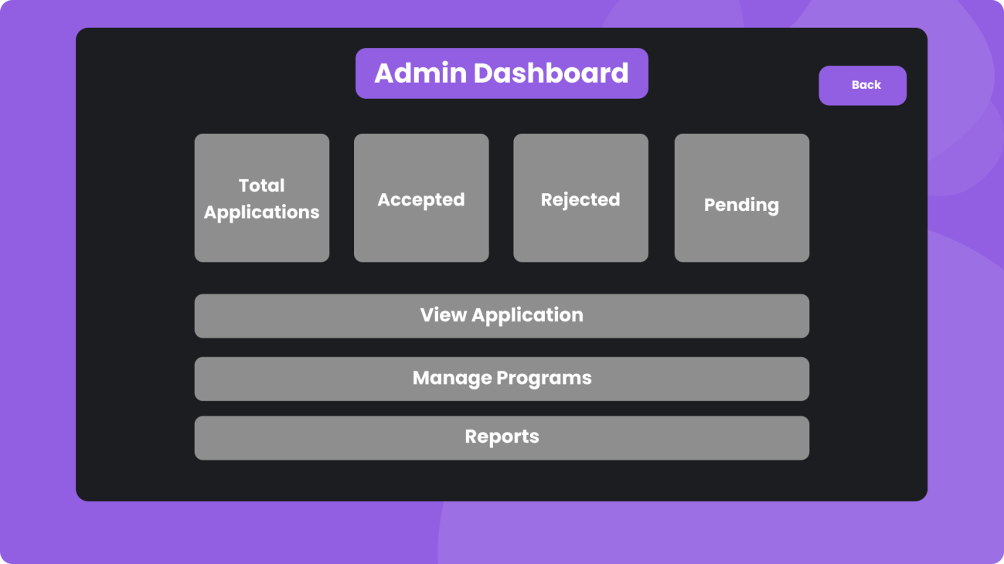
Figure: Admin Panel Page

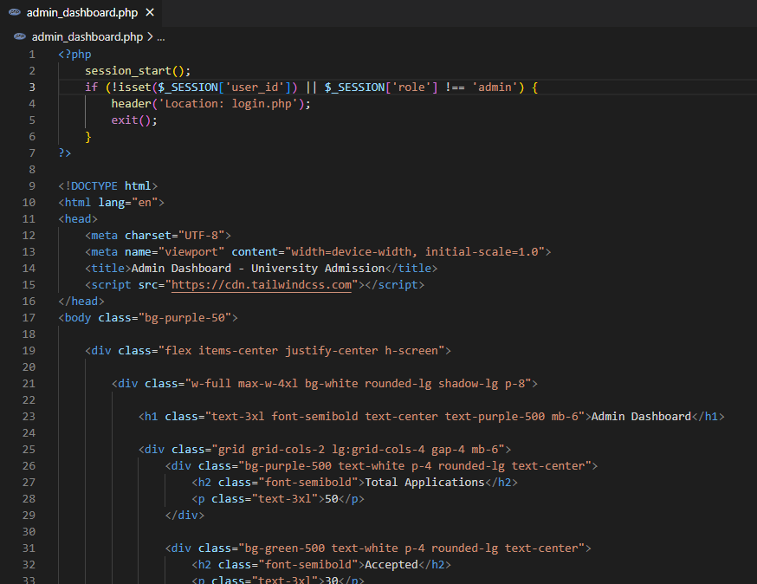

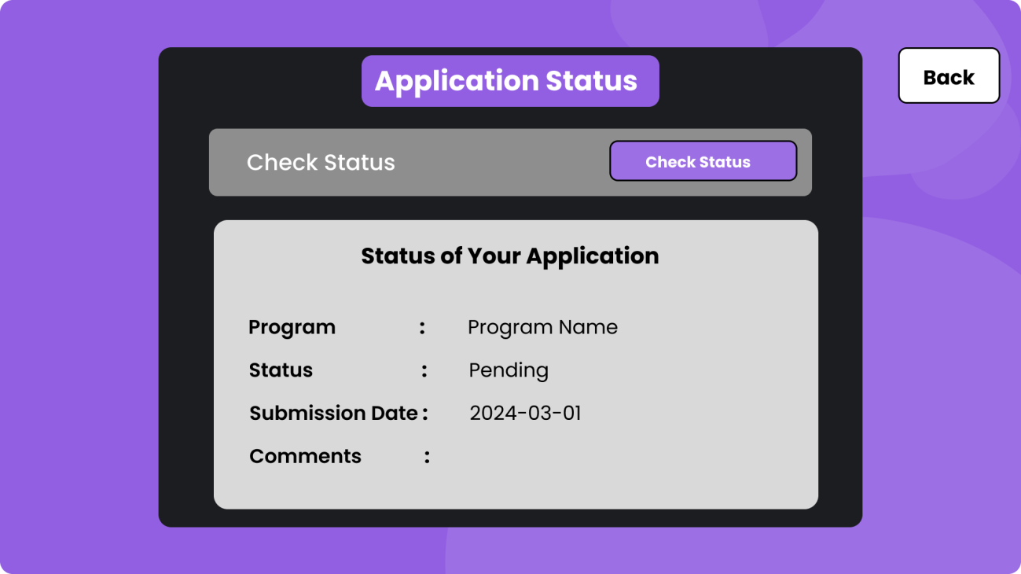
Figure: Application Status Page

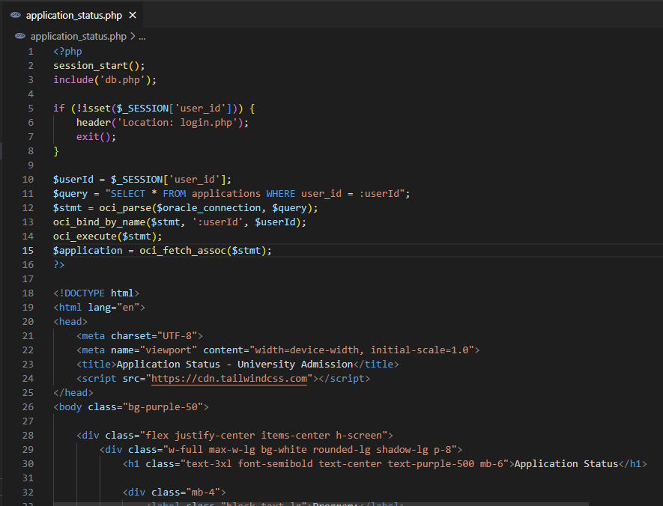

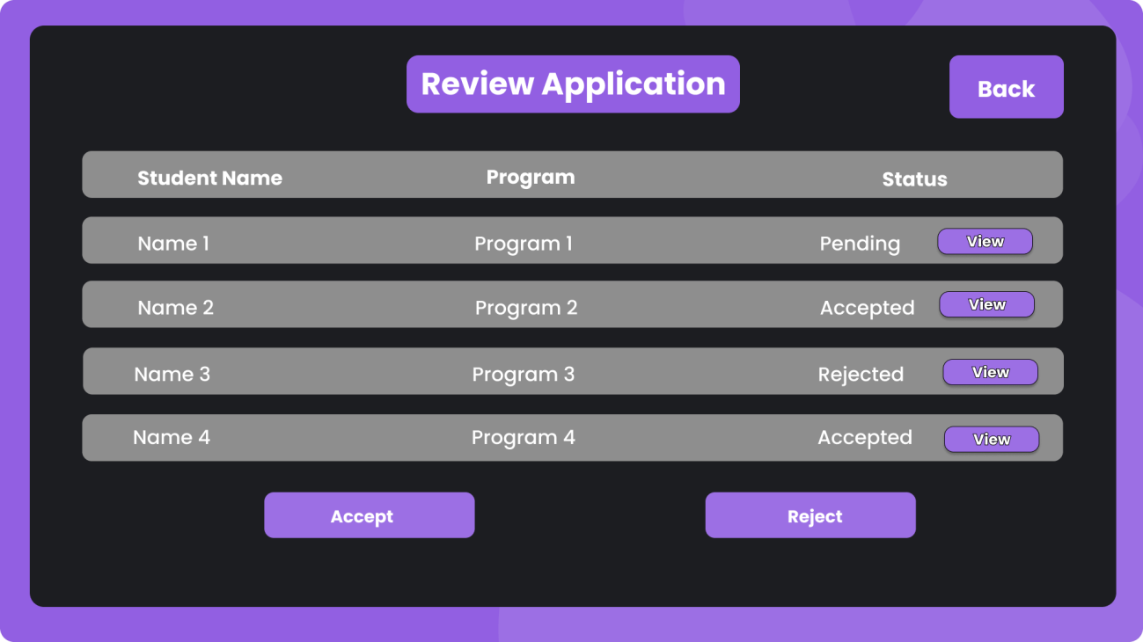
Figure: Review Application Page

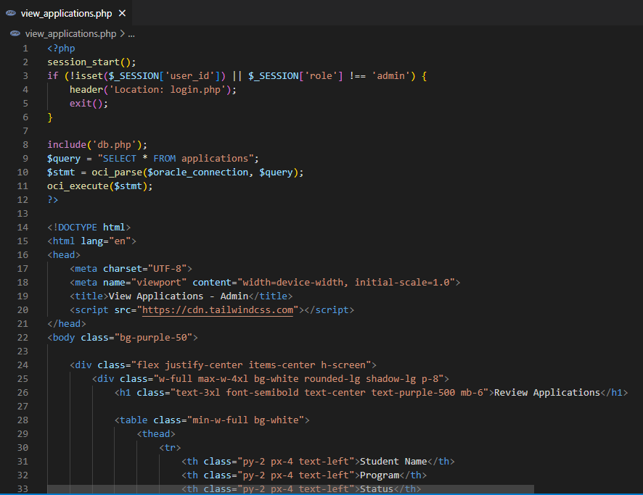

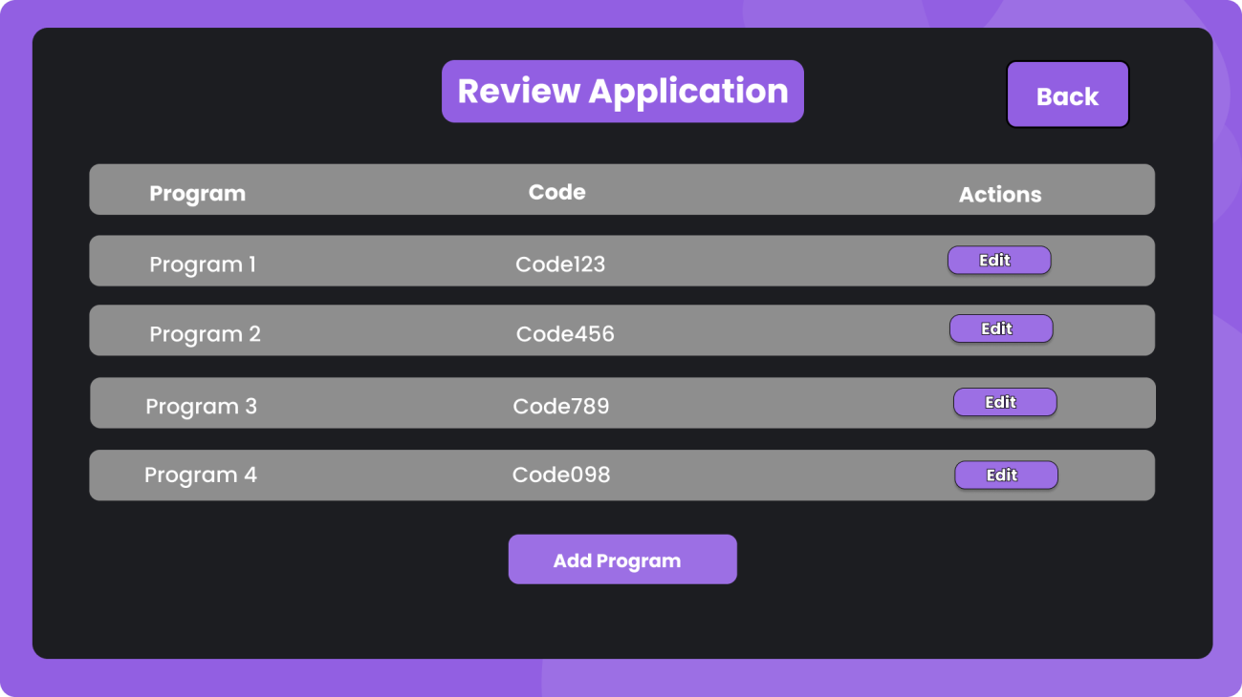
Figure: Review Page

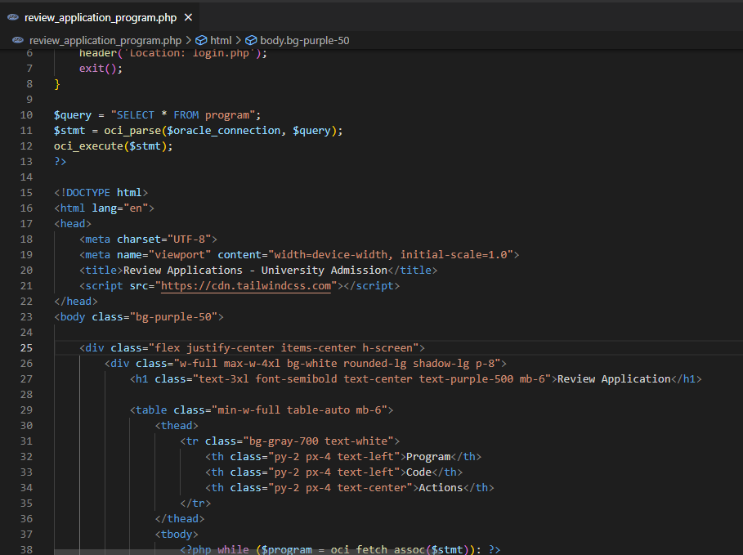
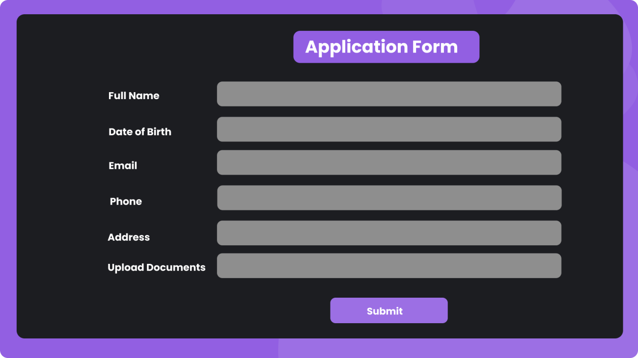
Figure: Application Form Page

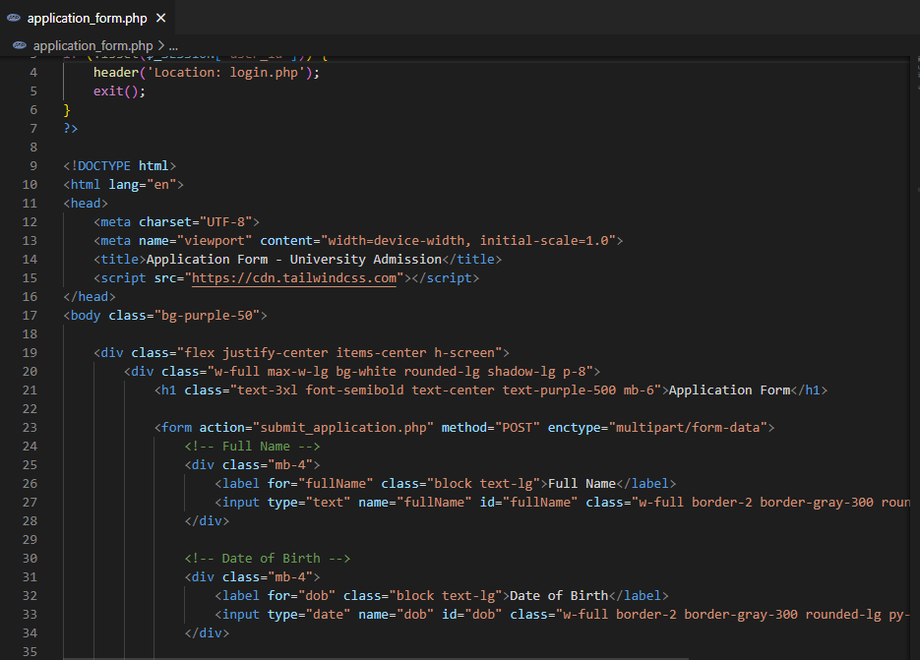

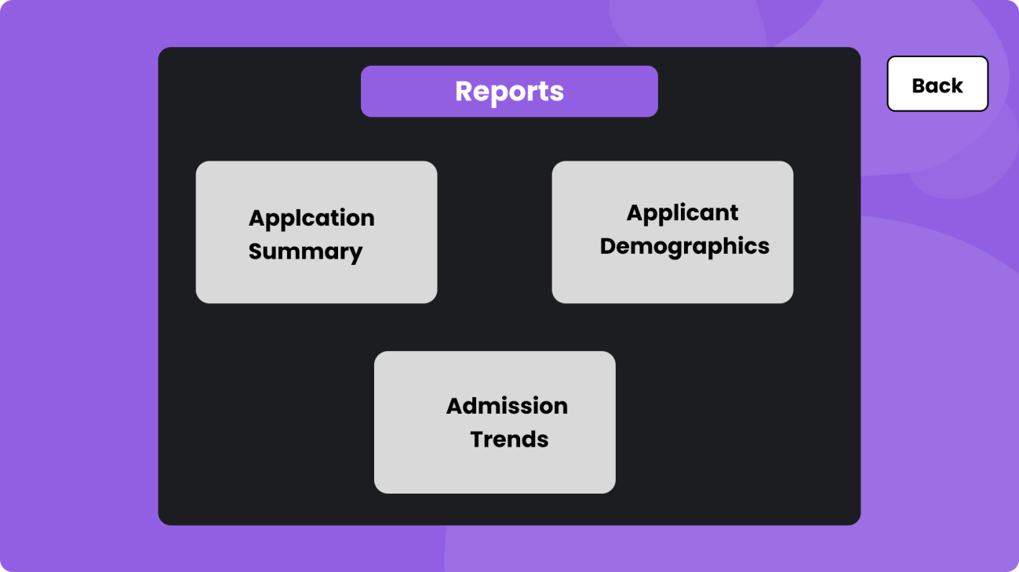
Figure: Reports Page
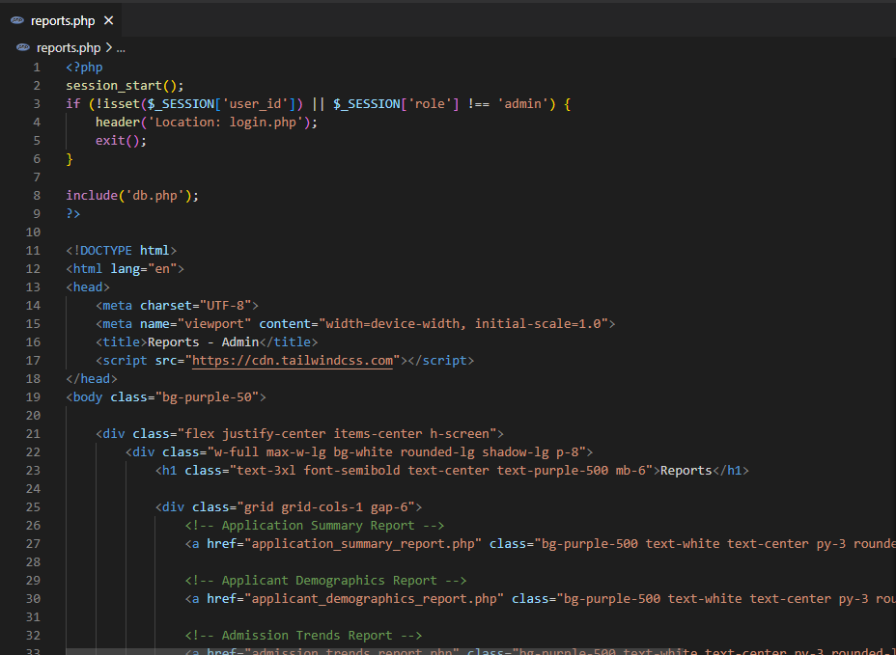

Database Connection:

Query Writing:
Exception Handling
1: Exception Handling - Null Value Insertion

DECLARE
v_student_id NUMBER := NULL;
BEGIN
INSERT INTO Student (student_id, name, phone, email, city, street_no, house_no)
VALUES (v_student_id, 'John Doe', '1234567890', 'john.doe@example.com', 'Dhaka', 'Street 1', 'House 101');
EXCEPTION
WHEN OTHERS THEN
DBMS_OUTPUT.PUT_LINE('Error: Cannot insert null value for student_id');
END;
/
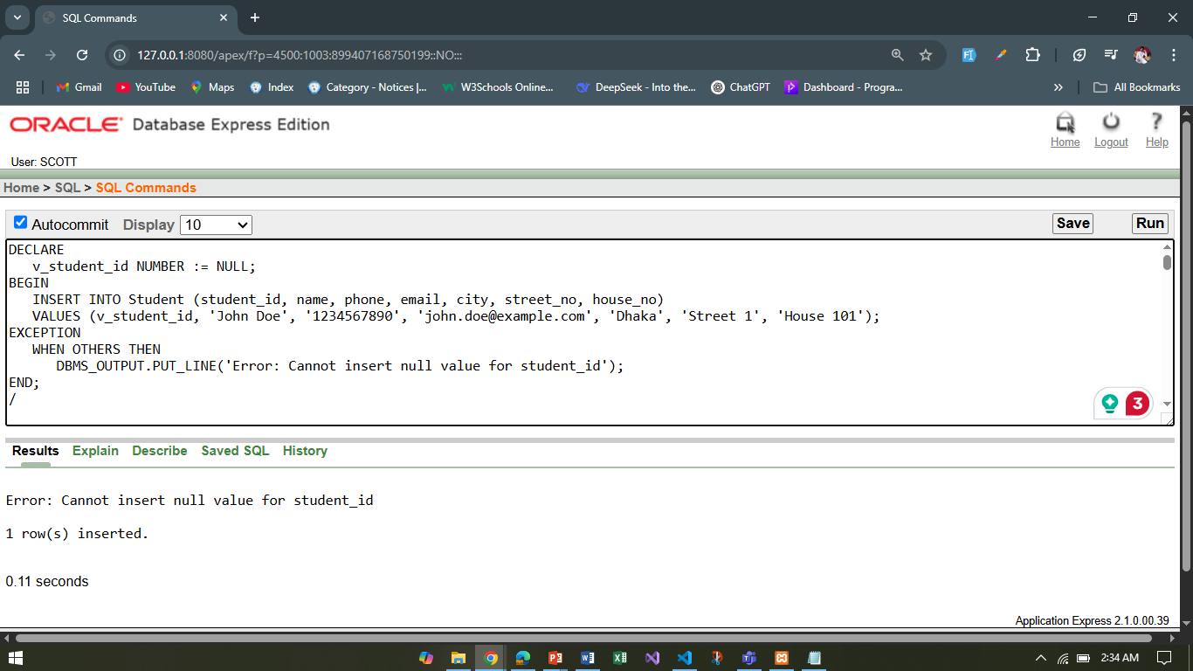

2: Exception Handling - Duplicate Entry

DECLARE
v_student_id NUMBER := 1;
BEGIN
INSERT INTO Student (student_id, name, phone, email, city, street_no, house_no)
VALUES (v_student_id, 'Jane Smith', '0987654321', 'jane.smith@example.com', 'Chittagong', 'Street 2', 'House 102');
EXCEPTION
WHEN DUP_VAL_ON_INDEX THEN
DBMS_OUTPUT.PUT_LINE('Error: Duplicate student_id exists');
WHEN OTHERS THEN
DBMS_OUTPUT.PUT_LINE('Some other error occurred');
END;
/
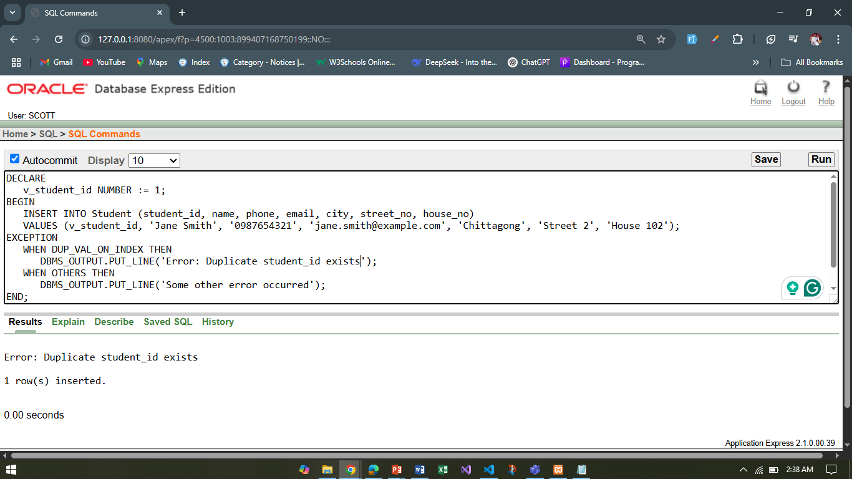

Implicit Locking
1: Implicit Locking - Update Student's Phone Number

BEGIN
UPDATE Student
SET phone = '9876543210'
WHERE student_id = 1;
COMMIT;
END;
/

2: Implicit Locking - Delete Student Record

BEGIN
DELETE FROM Student
WHERE student_id = 2;
COMMIT;
END;
/
Explicit Locking

1: Explicit Locking - Locking a Student Row for Update

BEGIN
SELECT student_id, name
FROM Student
WHERE student_id = 1
FOR UPDATE;

UPDATE Student
SET phone = '1234567890'
WHERE student_id = 1;
COMMIT;
END;
/

2: Explicit Locking - Locking Multiple Rows

BEGIN
SELECT student_id, name
FROM Student
WHERE city = 'Dhaka'
FOR UPDATE;

UPDATE Student
SET phone = '1112223333'
WHERE city = 'Dhaka';
COMMIT;
END;
/
Relational Algebra

1. Retrieve the names and emails of students who have been accepted:

Answer: π name, email (σ result_status = 'Accepted' (Application ⨝ Student))

2. Find all programs offered by the 'Computer Science' department:

Answer: π program_name (σ department_name = 'Computer Science' (DepartmentProgram))

3. Retrieve the names of students who applied to the 'Data Science' program:

Answer: π name (σ selected_program = 'Data Science' (Application ⨝ Student))

4. Get the list of all students who have submitted documents:

Answer: π student_id (Application ⨝ Document)

5. Find the average total marks of students who appeared in the admission test:

Answer: AVG(total_marks) (StudentTest ⨝ Test)

